GOPALGANJ SCIENCE AND TECHNOLOGY UNIVERSITY GOPALGANJ

RESEARCH PROPOSAL
Inequality of Garo Community : A Sociological Analysis in Mymensing District

Course Code: SOC412 | Year: Fourth
Semester: 1st | Department: Sociology
Submitted By | Submitted To
Name: | Supervisor / Course Teacher
Student ID: | Department of Sociology
Session: | Gopalganj Science and Technology
 | University

Date of Submission:
Date of Submission: August 14, 2026

TABLE OF CONTENTS
CHAPTER 1: INTRODUCTION 1
  - Background of the Study 1
  - Statement of the Problem 3
tudy 4
  - Rationale of the Study 5
. 6
CHAPTER 2: LITERATURE REVIEW 7
  - Selected Literature 7
  - Review of Previous Studies 9
  - Literature Gap 12
CHAPTER 3: THEORETICAL AND CONCEPTUAL FRAMEWORK 14
  - Social Exclusion Theory 14
  - Intersectionality Theory 15
  - Relative Deprivation Theory 16
  - Conceptual Framework 17
CHAPTER 4: METHODOLOGY 19
  - Research Design 19
  - Research Method 20
    - Quantitative Method 20
    - Qualitative Method 20
  - Sample Size 21
  - Population 21
  - Research Area 22
  - Ethical Consideration 22
  - Result and Discussion 23
CHAPTER 5: CONCLUSION 24
CHAPTER 6: REFERENCES 25
RESEARCH WORK PLAN 26

DECLARATION

I hereby declare that this research proposal, titled “Inequality of Garo Community : A Sociological Analysis in Mymensing District”, has been prepared as an academic research plan for the Department of Sociology, Gopalganj Science and Technology University.
The proposed study will examine inequality as a multidimensional social process, with particular attention to land and resource security, education, healthcare, livelihood and employment, income, infrastructure, institutional access, social participation, gender and geographical location.
The proposal does not present uncollected field information as established findings. The Result and Discussion section is presented as a proposed analytical plan and as expected areas for investigation. Primary data will be collected only after appropriate academic approval and with voluntary participation.

Researcher Department of Sociology

ACKNOWLEDGEMENT

I would like to express my gratitude to Almighty Allah for giving me the strength and opportunity to prepare this research proposal. I am grateful to my respected supervisor/course teacher for academic guidance, constructive suggestions and encouragement during the development of the research problem and methodological design.
I also acknowledge the academic contribution of the Department of Sociology, Gopalganj Science and Technology University. The department has provided the theoretical and methodological foundation necessary for examining social inequality, exclusion, social change and development.
I am thankful to the researchers, public institutions and development organizations whose published studies, census materials and reports have helped establish the background of the proposed research. Earlier studies on Garo land rights, livelihoods, health, property and social exclusion have been particularly useful for identifying the dimensions that require further integrated investigation.
Finally, I am grateful to my family, classmates and friends for their encouragement and support. I hope that this research will contribute to a better sociological understanding of inequality and inclusive development among Garo communities in the Mymensingh region.

CHAPTER ONE

INTRODUCTION

Background of the Study
The Garo people, commonly identifying themselves through names such as A’chik and Mande, are an important indigenous community of the north-eastern region of the Indian subcontinent. In Bangladesh, Garo settlements are concentrated particularly in the Mymensingh region and in neighbouring areas including Sherpur, Netrokona and Tangail.

The northern part of Mymensingh is geographically connected with the Garo Hills and the Meghalaya border, making the area important for understanding Garo history, identity and social change. The Bangladesh Population and Housing Census 2022 recorded a national Garo population of 76,846.

These aggregate figures demonstrate the significance of indigenous communities in Bangladesh’s social diversity, but national totals cannot by themselves explain how inequality is experienced in individual Garo settlements.

Garo society has distinctive cultural institutions, including matrilineal inheritance and clan-based organization. Historically, agriculture, forest resources and community networks have played important roles in livelihood and social life.
Over time, land-use change, market integration, education, migration, religious transformation and interaction with mainstream institutions have altered many aspects of everyday Garo life.

Socio-economic inequality in this context cannot be understood only through household income. It may include unequal access to productive land, secure tenure, quality education, healthcare, employment, infrastructure, credit, government services, political participation and social recognition.

For an indigenous community, institutional practices and geographical remoteness may further shape opportunities. The Garo Hills of northern Mymensingh provide a significant setting for examining these processes because ethnicity, rural livelihoods, border geography and access to public institutions intersect in the same social space.

Haluaghat is proposed as the principal study site, with selected adjoining Garo settlements considered where feasible. Land is particularly important because it is connected with livelihood, food security and long-term household security.

Changes in customary land relations, documentation problems, disputes and competition over productive resources may influence household vulnerability. Land insecurity can also interact with employment and income, creating cumulative disadvantage.

Education represents another important dimension. Even where basic schooling is available, distance, transportation costs, household resources and limited opportunities for higher education may influence continuation. Differences in educational attainment may later affect employment opportunities and income.

Healthcare access may also be unequal. Physical distance, transportation, treatment costs, communication difficulties and perceptions of institutional treatment can affect whether households obtain timely and appropriate services. Such barriers may become more significant for women and for households living in remote locations.
Employment and income are shaped by agriculture, wage labour, business, salaried employment, migration and livelihood diversification. These opportunities are not necessarily distributed equally. Household economic position, education, gender and geographical location may influence the range of available choices.
Therefore, the proposed research treats inequality as a connected set of social and economic processes rather than as a single indicator. The study will examine how different forms of disadvantage may reinforce each other and whether community networks and institutions provide protective resources.

Statement of the Problem
Existing evidence indicates that Garo communities have experienced important social and economic changes, while access to resources and institutions may remain uneven. The problem is not simply whether poverty exists, but how unequal opportunities are produced and maintained across different areas of social life.
Studies of Garo communities have examined land rights, property and inheritance, livelihood transformation, healthcare, gender and relations with state or local institutions. These studies provide valuable insights, but they often focus on a particular issue, settlement or population group.

As a result, the connections between different dimensions of inequality are less clearly understood. For example, land insecurity may affect livelihood options and household income. Lower income may restrict educational investment or healthcare use. Limited education may reduce access to formal employment. Poor infrastructure may intensify the effects of all these conditions
These relationships suggest that inequality should be examined as cumulative and multidimensional. There is also a need to consider differences within the Garo community. Gender, economic status, occupation and geographical remoteness may create different experiences.
A matrilineal social structure should not automatically be treated as evidence that women have equal opportunities in every sphere. The proposed research therefore seeks to investigate the major dimensions of socio-economic inequality among Garo households in the Mymensingh Garo Hills.

  - Objectives of the Study
General Objective
To examine the nature, dimensions and socio-economic consequences of inequality among the Garo people living in the Garo Hills of the Mymensingh region.

Specific Objectives

        - To identify the socio-economic condition in Garo Community
        - To investigate inequalities in educational access.
        - To analyze occupation, income, livelihood diversification

Rationale of the Study
The study is important because aggregate measures of poverty may conceal differences in access to land, education, health services and institutions. A multidimensional approach can reveal how material conditions and social relationships interact.
The research is also sociologically relevant because it connects structural factors with everyday experiences. It asks not only what resources households possess, but also whether they can effectively use institutions and opportunities available in the wider society.
The study may contribute to academic understanding of indigenous inequality in Bangladesh by focusing on a northern borderland context where geographical remoteness and cultural identity are important.
It may also help distinguish between disadvantages shared by many rural households and disadvantages that are linked specifically to ethnicity or institutional exclusion.
The study will further consider community strengths. Social networks, cultural organizations, women’s participation, local knowledge and livelihood diversification may help households manage constraints.

12

CHAPTER TWO LITERATURE REVIEW
Bal (2007)

Becoming the Garos of Bangladesh: Policies of Exclusion and the Ethnicisation of a ‘Tribal’ Minority.
Bal (2007) examined the historical relationship between the Garo community and state policies in the borderland of Bengal. The study explains how administrative and political processes influenced the ethnicisation of the Garo people and contributed to experiences of exclusion. It also shows that Garo identity was shaped through changing political circumstances, territorial boundaries and interactions with wider institutions. This study is important for the present research because it connects inequality with historical exclusion and institutional relations, rather than viewing disadvantage only as a matter of income.
The study further indicates that experiences of exclusion could strengthen community identity and internal solidarity. For the present research, this perspective is useful in understanding how historical processes may continue to influence access to resources, institutions and opportunities among Garo communities in Mymensingh.
Begum (2016)

A Relationship between Vulnerable Adivasi Garo Community and Local Actors in Bangladesh.
Begum (2016) focused on the relationship between the vulnerable Adivasi Garo community and local actors in Bangladesh. The study highlights the importance of interactions between the community and government, non-governmental and local actors. Such relationships can influence access to support, services and development opportunities. The study is relevant to the present research because institutional relationships are an important part of socio-economic inequality.
The findings also provide a basis for examining whether formal services and development programmes are equally accessible to Garo households. Therefore, the present study will consider institutional access together with education, healthcare, livelihood and other dimensions of inequality.

13

Dey (2015)

Resource Enclosure, Land Rights and Gender: A Case Study of the Matrilineal Garo Community of Modhupur Sal Forest.
Dey (2015) examined resource enclosure, land rights and gender among the matrilineal Garo community of the Modhupur Sal Forest. The study draws attention to changes in access to natural resources and land tenure, showing why land is a major issue in the social and economic security of Garo households. It also demonstrates that gender needs to be considered when examining land rights and resource access.
This study is directly relevant to the present research because land insecurity can affect livelihood, food security and household well-being. It also supports examining gender alongside economic and geographical conditions rather than assuming that matrilineal inheritance automatically produces equality in every area of social life.
Islam (2023)

Changing Patterns of Property Ownership and Inheritance System of the Garo Society in Bangladesh: An Overview.
Islam (2023) studied changing patterns of property ownership and inheritance in Garo society. The study discusses changes in traditional inheritance practices while noting the continuing importance of customary Garo culture. Property and inheritance are important because they influence household resources, economic security and relations within families and communities.
For the present study, Islam’s work helps explain why property ownership and inheritance should be considered as part of wider socio-economic inequality. Changes in customary practices may affect different households differently, making property and resource security important areas for further investigation in the Garo Hills of Mymensingh.

14

Mia and Rabbani (2024)

Transitioning Livelihood Strategies Among the Garo Community: A Case Study in Netrakona, Bangladesh.
Mia and Rabbani (2024) examined changing livelihood strategies among Garo communities in Durgapur and Kolmakanda of Netrokona. The study identifies changes associated with Christianity, NGOs, globalization and broader social development. It also highlights the importance of communication, transportation, education and institutional assistance in supporting livelihood opportunities.
The study is useful for the present research because livelihood transformation can change household income, employment security and dependence on traditional occupations. Its findings also suggest that infrastructure and institutional support may influence whether Garo households can benefit from changing economic opportunities.
Ananda (2020)

A Comparative Study of Socio-Economic Status between Ethnic (Garo) Community and Mainstream People of Bangladesh.
Ananda (2020) compared the socio-economic status of the Garo community with mainstream people in Bangladesh. The study draws attention to differences in areas such as land, education, employment, income and participation. This comparative perspective is important because inequality becomes clearer when opportunities and living conditions are examined across social groups.
For the present research, the study provides a useful basis for examining socio-economic disadvantage among Garo households. However, the proposed research will give greater attention to differences within the Garo community and to the ways in which gender, economic status and geographical location may shape unequal experiences.

15

Chowdhury et al. (2023)

Racism and Access to Maternal Health Care among Garo Indigenous Women in Bangladesh.
Chowdhury et al. (2023) examined racism and access to maternal healthcare among Garo indigenous women in Bangladesh. The study demonstrates that healthcare access is not determined only by the physical availability of a facility. Institutional experiences, social treatment and perceptions of discrimination can also influence whether people receive appropriate care.
This finding is relevant to the present study because health inequality may be produced through both economic and institutional barriers. It also highlights the importance of gender when examining access to services, particularly for women in disadvantaged or remote communities.
Jahan et al. (2026)

Analyzing Food Security and Livelihood Dynamics of the Indigenous Community in Bangladesh: A Post-COVID-19 Perspective.
Jahan et al. (2026) analyzed food security and livelihood dynamics among indigenous communities in Bangladesh from a post-COVID-19 perspective. The study is relevant to understanding how household livelihoods and food security can become vulnerable during wider social and economic changes. It also draws attention to the connection between livelihood conditions and household-level economic security.
For the present research, this work supports the inclusion of livelihood, income and food-related economic vulnerability when assessing inequality. It also helps broaden the analysis beyond single indicators and toward the multiple conditions that shape household well-being.

16

Synthesis of Previous Studies
The reviewed studies show that inequality among Garo communities is connected with several overlapping dimensions. Bal (2007) highlights historical exclusion and the role of state and political processes; Begum (2016) emphasizes relationships with local actors and institutions; Dey (2015) focuses on land, resources and gender; and Islam (2023) discusses property and inheritance. Mia and Rabbani (2024) draw attention to changing livelihoods and the importance of infrastructure and institutional support, while Ananda (2020) demonstrates socio-economic differences between Garo and mainstream communities. Chowdhury et al. (2023) show that institutional experiences can affect healthcare access, and Jahan et al. (2026) highlight livelihood and food-security vulnerability.
Taken together, the literature provides strong evidence that Garo inequality cannot be understood through income alone. Land and property, education, healthcare, employment, livelihood, infrastructure, institutional access and gender all have relevance. However, the studies often examine these issues separately or focus on locations such as Modhupur and Netrokona. Therefore, the present research seeks to bring these dimensions together in an integrated study of selected Garo settlements in Haluaghat, Mymensingh.

Literature Gap
First, a multidimensional gap exists because previous studies have addressed land, livelihood, healthcare, property, gender and exclusion, but these dimensions are often examined separately. Second, a geographical gap exists because important studies have focused on Modhupur, Tangail or Netrokona, while the Garo-inhabited northern Mymensingh borderland has its own geographical and institutional context. Third, more evidence is needed on how Garo households experience schools, healthcare facilities, markets, local administration and other public institutions. Finally, there is scope to examine how gender, household economic status and geographical remoteness interact in producing different experiences of inequality.

CHAPTER THREE
THEORETICAL AND CONCEPTUAL FRAMEWORK

Social Exclusion Theory
Social Exclusion Theory is useful for understanding inequality because it shifts attention from individual poverty to the processes through which people are prevented from fully participating in social, economic, political and institutional life.
Exclusion may result from limited resources, discriminatory practices, weak representation, geographical isolation or institutional arrangements that disadvantage particular groups.
For the present study, social exclusion can be examined through access to land, education, healthcare, employment, markets and government institutions. A household may have a formal entitlement to a service but still experience effective exclusion if the service is too distant, too costly or culturally difficult to use.
The theory also helps explain cumulative disadvantage. Limited educational access may reduce employment opportunities; low income may restrict healthcare use; and land insecurity may increase dependence on insecure labour.

Intersectionality Theory
Intersectionality Theory emphasizes that social categories such as ethnicity, gender and class can intersect to produce distinctive experiences of advantage and disadvantage. In the present study, Garo identity will be considered together with gender, household economic status and geographical location.
For example, a woman from a low-income household living in a remote settlement may experience barriers that cannot be explained by ethnicity, gender or poverty separately. The framework therefore encourages analysis of differences within the community.
The Garo community should not be treated as socially homogeneous. Households may differ in landholding, occupation, education, income, migration networks and proximity to public services.

Relative Deprivation Theory
Relative Deprivation Theory helps explain inequality through people’s perceptions of disadvantage in comparison with others. Inequality is not experienced only through absolute lack of resources; people may also feel deprived when they believe that other groups or households have better access to opportunities, services, land, education, employment or social recognition.
In this study, the theory will help examine how Garo people perceive differences between their own households and better-positioned households or mainstream communities. Such perceptions may influence feelings of exclusion, dissatisfaction, social participation and expectations about development.

Conceptual Framework
INTERMEDIATE FACTORS

Land / resource security Education
Healthcare access Employment & livelihood Institutional access Social participation
STRUCTURAL FACTORS

Garo identity Gender Economic status
Geographical remoteness Infrastructure Institutional practices
INEQUALITY OUTCOMES

Income inequality Employment inequality Education gap
Health inequality Service-access gap Perceived exclusion
The conceptual framework treats socio-economic inequality as the main outcome. Structural factors influence intermediate conditions, which in turn shape inequality outcomes. The framework also recognizes cumulative feedback between these levels.

CUMULATIVE FEEDBACK / REINFORCEMENT

  - Research Design

CHAPTER FOUR METHODOLOGY

The study will use a mixed-method research design combining quantitative and qualitative approaches. The research will be cross-sectional, meaning that primary data will be collected during a defined period of fieldwork. The quantitative component will provide household-level information on demographic and socio-economic conditions, while the qualitative component will explore lived experiences, perceptions of inequality, institutional barriers, gender and community participation.

Research Method
The study will combine quantitative and qualitative methods so that measurable household conditions can be examined together with people’s lived experiences and perceptions. This combination is appropriate for a multidimensional study of inequality.

Quantitative Method
A structured household questionnaire will be used to collect information on household composition, education, land, occupation, income, health, housing, water and sanitation, transport, credit, social protection and institutional participation.

Qualitative Method
Qualitative data will be collected through in-depth interviews, key informant interviews and observation. Interviews will explore experiences of land insecurity, discrimination, healthcare access, education, employment, gender roles, institutional interaction and social participation.
  - Sample Size
Approximately 150 Garo household will be targeted for the household survey. In addition, approximately 15-20 qualitative participants or key informants maybe selected. The final sample will depend on field access, respondent availability and academic approval.

Population
The study population will consist primarily of adult members of Garo households living in the selected study settlements. Community leaders, teachers, health workers, local representatives and development actors may also be included in the qualitative component where their knowledge is relevant.
According to the Bangladesh Population and Housing Census 2022, the national Garo population was 76,846. This figure provides the broader population context for the proposed study; the field research itself will focus on selected Garo-inhabited settlements in Haluaghat, Mymensingh.
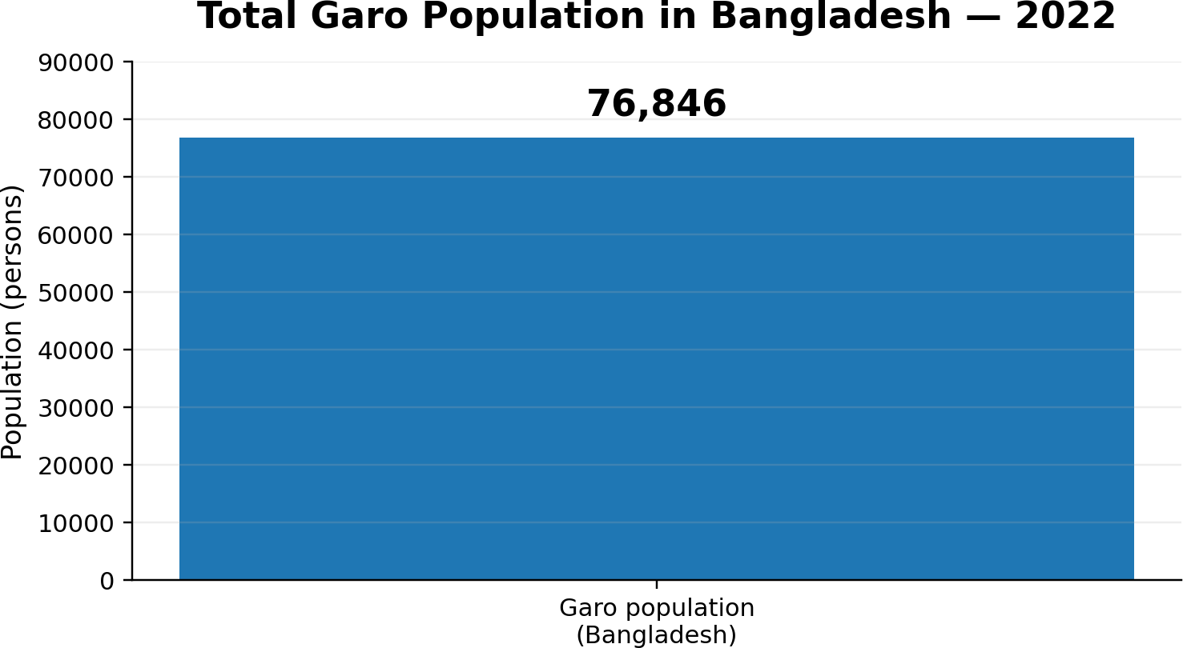

Figure 3. Total Garo population in Bangladesh according to the Population and Housing Census 2022.

The chart represents the national Garo population only and should not be interpreted as the population of Haluaghat or the selected study settlements.

Research Area
The principal study area will be Haluaghat Upazila of Mymensingh District, focusing on selected Garo-inhabited settlements. Haluaghat is a northern upazila of Mymensingh and lies near the international border with India. The location is suitable for the study because indigenous settlement, rural livelihood, border geography and access to public services intersect here.
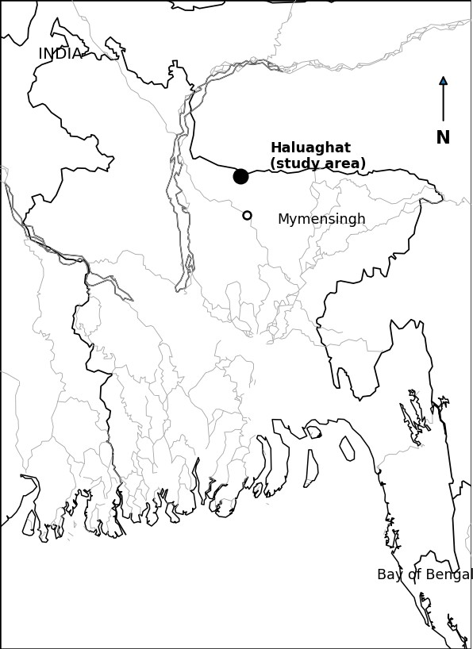
Figure 2. Location of the proposed study area (Haluaghat) in the Mymensingh region of Bangladesh.

Ethical Consideration
Participation will be voluntary. Participants will be informed about the purpose of the study and will have the right to decline any question or withdraw from participation. Names and identifying details will be kept confidential.
Sensitive topics such as land disputes, discrimination, health and household finances will be discussed respectfully. Information will be used only for academic purposes and reported in a way that does not unnecessarily identify individual participants.

Result and Discussion

The quantitative and qualitative data will be brought together in the Result and Discussion section. The analysis will first describe the socio-economic characteristics of the surveyed households and then examine inequality across land, education, healthcare, employment, income, infrastructure and institutional access.
Quantitative findings will be presented using tables, frequencies, percentages, means and cross-tabulations where appropriate. Differences by gender, economic status, occupation and geographical location will be examined where the sample permits.
Qualitative findings will be organized around major themes such as land security, educational barriers, healthcare access, livelihood vulnerability, gender, institutional exclusion, cultural recognition and community resilience. Participants’ experiences will be used to explain patterns identified through the household survey.
The discussion will interpret the results through Social Exclusion Theory, Intersectionality Theory and Relative Deprivation Theory. The purpose will be to connect observed inequalities with structural, institutional and household-level processes rather than treating inequality as a single measure of income.
Because this is a research proposal, the final numerical results and substantive conclusions will be determined only after field data collection and analysis. No uncollected field information will be presented as an established finding.

CHAPTER FIVE
CONCLUSION

Inequality among the Garo people of the Mymensingh Garo Hills is expected to be a multidimensional social issue rather than a simple difference in income. Land security, education, healthcare, employment, income, infrastructure and institutional participation may interact to shape unequal opportunities. The proposed study uses Social Exclusion Theory, Intersectionality Theory and Relative Deprivation Theory to understand both the structural processes that restrict participation and the ways ethnicity, gender, economic status, geography and perceptions of disadvantage may combine to produce different experiences within the community. The mixed-method design will connect
household-level conditions with lived experiences and perceptions, allowing the study to examine both measurable inequalities and the institutional or social processes through which inequality is experienced. By focusing on selected Garo settlements of Haluaghat in Mymensingh, the research seeks to provide an integrated sociological understanding of how land insecurity, educational and healthcare barriers, livelihood vulnerability, unequal institutional access and geographical remoteness may reinforce one another. At the same time, the study recognizes community strengths such as social networks, cultural knowledge, women’s participation and local forms of resilience. Since this is a research proposal, the final findings and conclusions will be determined only after field data collection and analysis. Overall, the proposed research aims to provide an evidence-based account of socio-economic inequality among the Garo people and to contribute to a clearer understanding of the conditions needed for more inclusive, equitable and culturally respectful development.

CHAPTER SIX REFERENCES

Ananda, K. K. (2020). A Comparative Study of Socio-Economic Status between Ethnic (Garo) Community and Mainstream People of Bangladesh.
Ananda, K. K. (2020). A Comparative Study of Socio-Economic Status between Ethnic (Garo) Community and Mainstream People of Bangladesh.
Bal, E. W. (2007). Becoming the Garos of Bangladesh: Policies of exclusion and the ethnicisation of a ‘Tribal’ minority. South Asia: Journal of South Asian Studies, 30(3), 439–455. https://doi.org/10.1080/00856400701714062
Bangladesh Bureau of Statistics. (2022). Population and Housing Census 2022: District Report—Mymensingh. Statistics and Informatics Division, Ministry of Planning, Government of Bangladesh.
Begum, F. (2016). A Relationship between Vulnerable Adivasi Garo Community and Local Actors in Bangladesh.
Chowdhury, S. K., et al. (2023). Racism and access to maternal health care among Garo indigenous women in Bangladesh: A qualitative descriptive study. PLOS ONE.
Dey, S. (2015). Resource Enclosure, Land Rights and Gender: A Case Study of the Matrilineal Garo Community of Modhupur Sal Forest. Empowerment: A Journal of Women for Women, 22.
Islam, M. R. (2023). Changing Patterns of Property Ownership and Inheritance System of the Garo Society in Bangladesh: An Overview. The Jahangirnagar Review, Part II: Social Science, 46(1).
Jahan, H., Jannat, A., Noman, M. A. A., Siddika, S., et al. (2026). Analyzing food security and livelihood dynamics of the indigenous community in Bangladesh: A post-COVID-19 perspective. Food and Energy Security, 15(1).
Mia, M., & Rabbani, G. (2024). Transitioning Livelihood Strategies Among the Garo Community: A Case Study in Netrakona, Bangladesh. Journal of Population and Development, 5(1), 73–87. https://doi.org/10.3126/jpd.v5i1.67564
Sen, A. (1999). Development as Freedom. Oxford University Press.
Silver, H. (1994). Social exclusion and social solidarity: Three paradigms. International Labour Review, 133(5–6), 531–578.
United Nations / UNDP Bangladesh. Relevant reports on indigenous communities, inclusion and Garo livelihoods.
Bangladesh Bureau of Statistics. Population and Housing Census 2022, District Report: Mymensingh—district and upazila maps.
Local Government Engineering Department (LGED). Haluaghat Upazila administrative and road map.
Bal, E. W. (2007). Becoming the Garos of Bangladesh: Policies of exclusion and the ethnicisation of a
·Tribal· minority. South Asia: Journal of South Asian Studies, 30(3), 439·455. https://doi.org/10.1080/00856400701714062
Bangladesh Bureau of Statistics. (2022). Population and Housing Census 2022: District Report·Mymensingh. Statistics and Informatics Division, Ministry of Planning, Government of Bangladesh.
Begum, F. (2016). A Relationship between Vulnerable Adivasi Garo Community and Local Actors in Bangladesh.
Chowdhury, S. K., et al. (2023). Racism and access to maternal health care among Garo indigenous women in Bangladesh: A qualitative descriptive study. PLOS ONE.
Dey, S. (2015). Resource Enclosure, Land Rights and Gender: A Case Study of the Matrilineal Garo Community of Modhupur Sal Forest. Empowerment: A Journal of Women for Women, 22.
Islam, M. R. (2023). Changing Patterns of Property Ownership and Inheritance System of the Garo Society in Bangladesh: An Overview. The Jahangirnagar Review, Part II: Social Science, 46(1).
Jahan, H., Jannat, A., Noman, M. A. A., Siddika, S., et al. (2026). Analyzing food security and livelihood dynamics of the indigenous community in Bangladesh: A post-COVID-19 perspective. Food and Energy Security, 15(1).
Mia, M., & Rabbani, G. (2024). Transitioning Livelihood Strategies Among the Garo Community: A Case Study in Netrakona, Bangladesh. Journal of Population and Development, 5(1), 73·87. https://doi.org/10.3126/jpd.v5i1.67564
Sen, A. (1999). Development as Freedom. Oxford University Press.
Silver, H. (1994). Social exclusion and social solidarity: Three paradigms. International Labour Review, 133(5·6), 531·578.
United Nations / UNDP Bangladesh. Relevant reports on indigenous communities, inclusion and Garo livelihoods.
Bangladesh Bureau of Statistics. Population and Housing Census 2022, District Report: Mymensingh·district and upazila maps.
Local Government Engineering Department (LGED). Haluaghat Upazila administrative and road map.

RESEARCH WORK PLAN

Activity | Proposed Period
Literature review and proposal refinement | Weeks 1–2
Tool/questionnaire preparation and pre-testing | Week 3
Field data collection | Weeks 4–6
Data organization and transcription | Week 7
Quantitative and qualitative analysis | Weeks 8–9
Drafting findings and discussion | Weeks 10–11
Final writing, revision and submission | Week 12
The work plan is indicative and may be adjusted according to departmental approval, field accessibility and the availability of respondents.

Researcher

